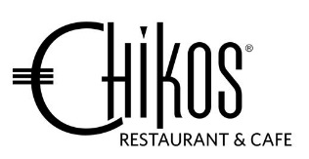
Chikos Set Menu

$82.00 per person
-----------------------------------------------------------------------------------------
Entrée
Chiko’s Grand Selection Platter
Pork tostada, mussel fritas, seared angus beef Thai style,
chicken karaage, prawns, lamb fajitas, baby cos and herb toast

Main
Free Ranged Chicken Breast
Apricot bacon bread pudding, roasted mushroom and mustard cream sauce

or

Braised Lamb Shank
Chorizo quinoa risotto, green beans, tequila tomato salsa

or

Citrus Cured King Salmon Fillet
Curry pumpkin, black rice risotto, wilted kale, rhubarb,
atchara, masala tomato emulsion

Dessert
Chiko’s Sungka Tasting Desserts Platter
Layered hazelnut chocolate, almond pannacotta, ice cream
Miniature of Verrine – malibu coco brulee, grand marnier fruit compote

--------------------------------------------------------------------------------------------------------
N may contain Nuts or traces of – G contains gluten – D contains dairy – V vegetarian

