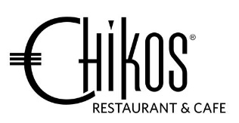
Chikos Degustation Menu

$95 per person
-----------------------------------------------------------------------------------------
To Begin
Roeless Scallops
Cucumber, aubergine torta, chipotle rouille
or

Blackened Venison Loin
Cauli atchara, grapes, beetroot hummus, pomegranate dressing

Soup
Mixed Roasted Mushroom & Truffle scented Cream Soup
Avocado-yuzu wantons

Cleanser
Blackcurrant Sorbet

Main
Red Snapper
Egg parme-floss, butter agria, capers sorel tomato salsa, miso tamarind emulsion
or

Angus Beef Sirloin
Ox tail ravioli, spinach, cream peppercorn reduction
or

Duck Leg Confit
Crème parsnips, kumara, wilted rocket, red currant jus

Dessert
Valrhona Chocolate
Orange, coffee & Mazuran port berries
or

Passionfruit Cheese Bavaroise
Salted caramel, dacquoise crumb

