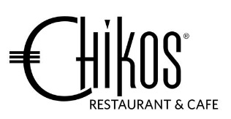
Chikos Set Menu

$78 per person
-----------------------------------------------------------------------------------------
Entrée
Black Tiger Prawns Parcel
cashew nuts and glass noodles with tom yum mayo

or

Grilled Halloumi Mazuran Port
spiced apple compote and sourdough

Main
Black Angus Beef Fillet
confit of new potato/field mushroom/
creme puree of cauliflower/soybeans/shiraz reduction

or

King Salmon Fillet
potato rosti crust/curry pumpkin puree/orange rhubarb/
masala tomato emulsion

or

Free Range Chicken Breast
stuffed with porcini ham fennel/cheese apple tart/
glazed spinach/mustard mushroom reduction

Dessert
Varhona Chocolate
Mango and coconut/Malibu anglaise
or

Summer Berries – Eton Mess
Mascarpone cream, mixed berries, compote & meringue crunch

