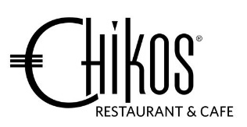
Chikos Set Menu

$72.00 per person
-----------------------------------------------------------------------------------------
Entrée
Black Tiger Prawns Parcel
Cashew nuts and glass noodles with tom yum mayo

or

Grilled Halloumi, Mazuran Port
Spiced apple compote and sour dough

Main
Black Angus Beef Fillet, Confit of new potato, Foiled Mushroom
Creme puree, cauliflower, fava beans, shiraz reduction

or

King Salmon
Curry pumpkin puree, soba sesame noodles, orange rhubarb,
masala tomato emulsion

or

Free Range Chicken Breast
Stuffed with porcini ham fennel, chestnut prune tart, glazed spinach,
mustard mushroom reduction

Dessert
Varhona Chocolate
Mango and coconut study
or

Summer Berries – Eton Mess
Mascarpone cream, mixed berries, compote & meringue crunch

--------------------------------------------------------------------------------------------------------
N may contain Nuts or traces of – G contains gluten – D contains dairy – V vegetarian

